EX 2: Data Story Using Visualizations

Aim
To create a data story from the May 2022 E-Commerce Product Pricing dataset by generating 3 to 5 visualizations to identify pricing trends, product category patterns, and anomalies across various e-commerce platforms.

Algorithm
- Start the program.
- Import the required Python libraries such as Pandas, Matplotlib, and Seaborn.
- Load the May 2022 E-Commerce Product Pricing dataset into a Pandas DataFrame using the read_csv() function.
- Examine the dataset and perform basic preprocessing, if required.
- Generate 3 to 5 visualizations such as Bar Chart, Pie Chart, Histogram, Box Plot, and Scatter Plot using suitable columns from the dataset.
- Analyze the visualizations to identify pricing trends, category-wise product distribution, and unusual price variations.
- Interpret the observations and create a meaningful data story based on the generated charts.
- Display all visualizations.
- Stop the program.

Procedure
- Open the Kaggle website and search for the May 2022 E-Commerce Product Pricing Dataset.
- Download the dataset in CSV (Comma-Separated Values) format and save it on the local system.
- Open the downloaded dataset in Microsoft Excel and verify the product details, pricing columns, and category information.
- If required, select the necessary records (e.g., 198 rows) and save the dataset as a new CSV file for analysis.
- Open Jupyter Notebook, Google Colab, Visual Studio Code, or any Python IDE.
- Import the required Python libraries such as Pandas for data manipulation and Matplotlib and Seaborn for data visualization.
- Load the dataset into a Pandas DataFrame using the pd.read_csv() function.
- Create 3 to 5 visualizations such as Bar Chart, Pie Chart, Histogram, Box Plot, and Scatter Plot to analyze product prices and category distribution.
- Examine the visualizations to identify pricing trends, category-wise patterns, and anomalies across different e-commerce platforms.
- Interpret the results and prepare a meaningful data story based on the visualizations.
- Display all the charts and summarize the key findings.

Python Program

Program 1: Bar Chart – Product Count by Category

# Program 1: Bar Chart
import pandas as pd
import matplotlib.pyplot as plt
# Load the dataset
df = pd.read_csv("Data Set.csv")
# Count products in each category
category_count = df['Category'].value_counts()
# Create Bar Chart
plt.figure(figsize=(8,5))
category_count.plot(kind='bar')
plt.title("Product Count by Category")
plt.xlabel("Category")
plt.ylabel("Number of Products")
plt.show()

Program 2: Pie Chart – Product Category Distribution

# Program 2: Pie Chart
import pandas as pd
import matplotlib.pyplot as plt
# Load the dataset
df = pd.read_csv("Data Set.csv")
# Count products in each category
category_count = df['Category'].value_counts()
# Create Pie Chart
plt.figure(figsize=(7,7))
category_count.plot(kind='pie', autopct='%1.1f%%')
plt.title("Product Category Distribution")
plt.ylabel("")
plt.show()

Program 3: Histogram – Final MRP Distribution

# Program 3: Histogram

import pandas as pd
import matplotlib.pyplot as plt

# Load the dataset
df = pd.read_csv("Data Set.csv")

# Remove extra spaces from column names
df.columns = df.columns.str.strip()

# Create Histogram
plt.figure(figsize=(8,5))
plt.hist(df["Final MRP Old"], bins=10, edgecolor="black")

plt.title("Distribution of Final MRP Old")
plt.xlabel("Final MRP Old")
plt.ylabel("Frequency")

plt.grid(True)

plt.show()

Program 4: Box Plot – Final MRP

# Program 4: Box Plot

import pandas as pd
import matplotlib.pyplot as plt

# Load the dataset
df = pd.read_csv("Data Set.csv")

# Remove extra spaces
df.columns = df.columns.str.strip()

# Create Box Plot
plt.figure(figsize=(6,5))
plt.boxplot(df["Final MRP Old"])

plt.title("Box Plot of Final MRP Old")
plt.ylabel("Final MRP Old")

plt.grid(True)

plt.show()

Program 5: Scatter Plot – TP 1 vs Final MRP

# Program 5: Scatter Plot

import pandas as pd
import matplotlib.pyplot as plt

# Load the dataset
df = pd.read_csv("Data Set.csv")

# Remove extra spaces
df.columns = df.columns.str.strip()

# Create Scatter Plot
plt.figure(figsize=(8,5))
plt.scatter(df["TP 1"], df["Final MRP Old"])

plt.title("TP 1 vs Final MRP Old")
plt.xlabel("TP 1")
plt.ylabel("Final MRP Old")

plt.grid(True)

plt.show()

Input Dataset
Data Set.csv

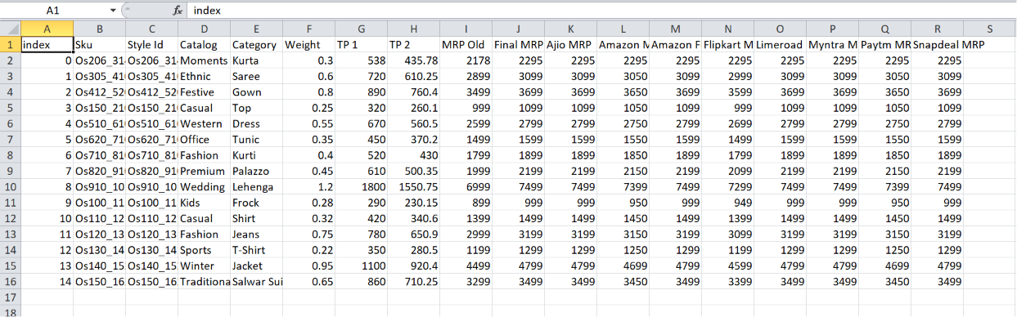

Output

Program 1
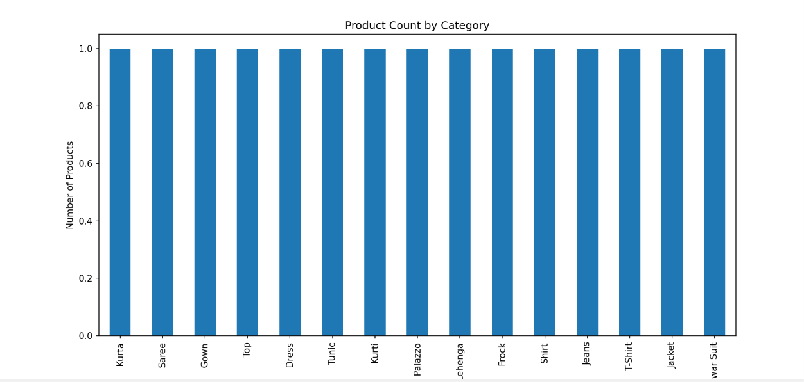

Program 2
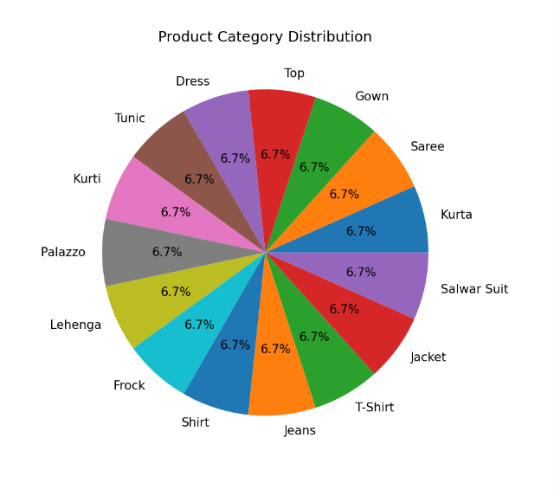

Program 3
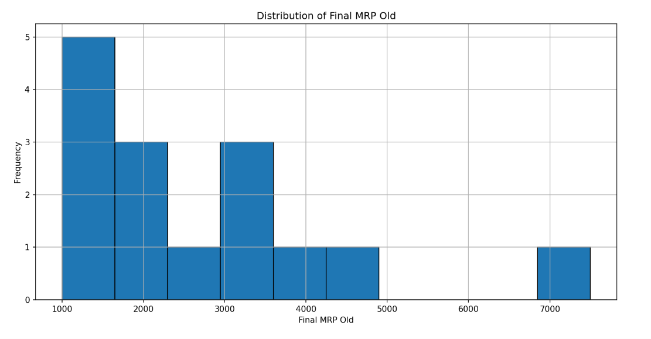

Program 4
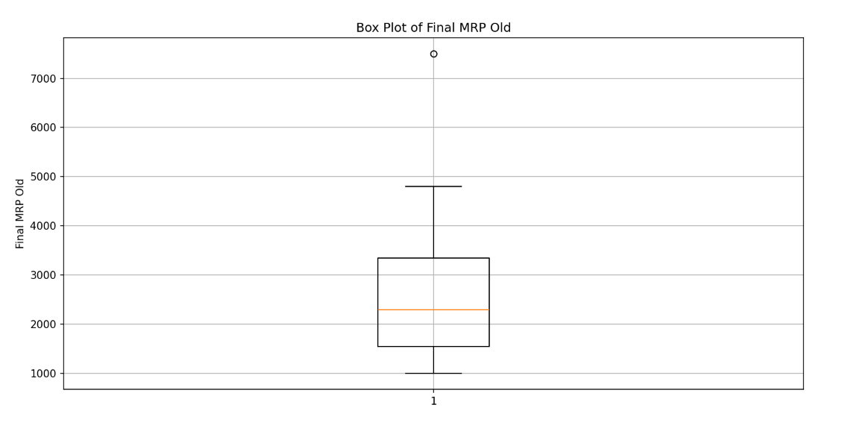

Program 5

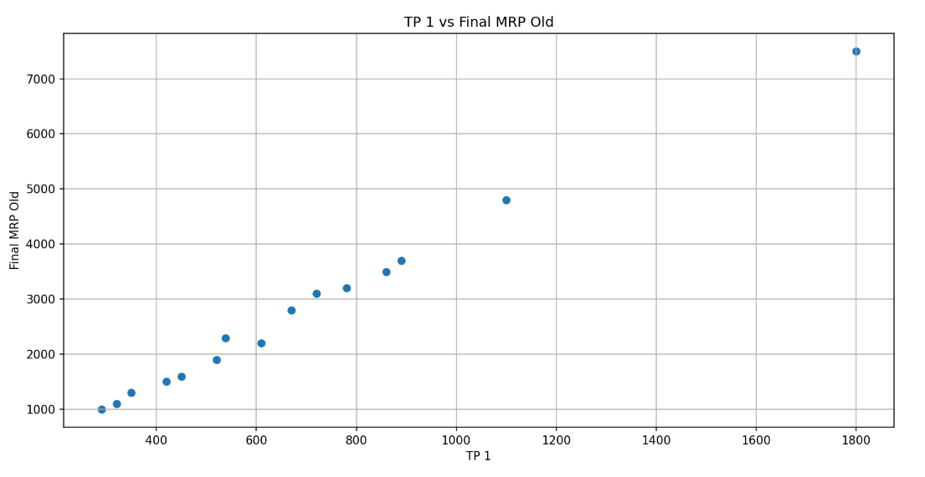

Result
Thus, a data story was successfully created from the E-Commerce Product Pricing dataset using various visualizations such as Bar Chart, Pie Chart, Histogram, Box Plot, and Scatter Plot. The visualizations helped identify product distribution, pricing trends, patterns, and anomalies in the dataset successfully.

